Independent-Samples t-Test – (Violent Crimes) – Answer Key
A licensed psychologist conducted an experiment examining the effect of weapons used during violent crimes on juror sentencing. One group of participants read a scenario in which an adult male criminal used a gun as a weapon. The second group of participants was presented a scenario in which an adult male criminal used another type of weapon. The sentence term, in years, is listed in the table. Do these data indicate that using a gun in a violent crime results in a different sentence length than using some other weapon?

Step 1. State your hypotheses.
a. Is it a one-tailed or two-tailed test?
Two-tailed

b. Research hypotheses
H_{A}: The sentence length of criminals who use a gun when committing a violent crime will differ
from those who use another type of weapon.

H₀: The sentence length of criminals who use a gun when committing a violent crime will not differ from those who use another type of weapon.

c. Statistical hypotheses
H_{A}: μ_{gun} - μ_{other weapon} ≠ 0

H₀: μ_{gun} - μ_{other weapon} = 0

Step 2. Set the significance level ➔ α = .05 Determine t_{crit}. + 2.228

Step 3. Compute the appropriate statistical test.
Gun  (X₁) |  | X – | (X –)²
5 | 7.5 | -2.5 | 6.25
7 |  | -0.5 | 0.25
3 |  | -4.5 | 20.25
12 |  | 4.5 | 20.25
10 |  | 2.5 | 6.25
8 |  | 0.5 | 0.25
ΣX = 45
= 7.5 |  |  | SS = Σ(X –)² = 53.5
SS₁ = 53.5 SS₂ = 17.5

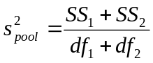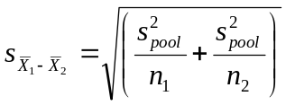

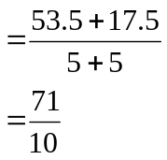
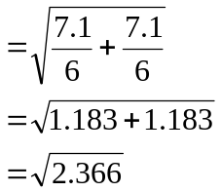

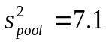
Other Weapon  (X₂) |  | X – | (X –)²
2 | 3.5 | -1.5 | 2.25
3 |  | -0.5 | 0.25
1 |  | -2.5 | 6.25
6 |  | 2.5 | 6.25
4 |  | 0.5 | 0.25
5 |  | 1.5 | 2.25
ΣX = 21 |  |  | SS = Σ(X –)² = 17.5
= 3.5
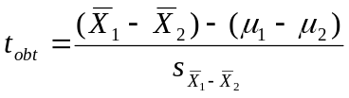
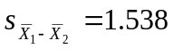

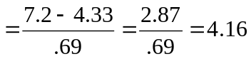

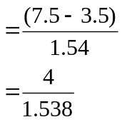

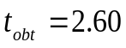
Step 4. Make a decision. Determine whether the value of the test statistic is in the critical region. Draw a picture.
Is t_{obt} in the critical region? Yes t_{obt} = 2.60
Should you reject or retain the H₀? reject

t_{crit} = -2.228 t_{crit} = +2.228

Step 5. Report the statistical results.

t(10) = 2.60, p < .05

Step 6. Write a conclusion.

The sentence length for a criminal using a gun in a violent crime (M = 7.5) is significantly longer than those who use another type of weapon (M = 3.5), t(10) = 2.60, p < .05.

Step 7. Compute the estimated d.
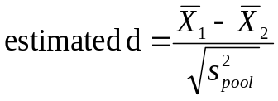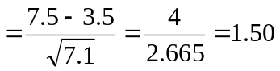d Effect Size
0.2 Small effect
0.5 Medium effect
0.8 Large effect

Step 8. Compute r² and write a conclusion.

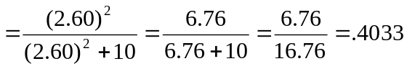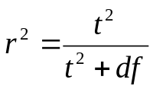r2 Percentage of Variance Explained
0.01 Small effect
0.09 Medium effect
0.25 Large effect

Type of weapon used during commission of a violent crime accounts for 40.33% of the variance in sentence length.

